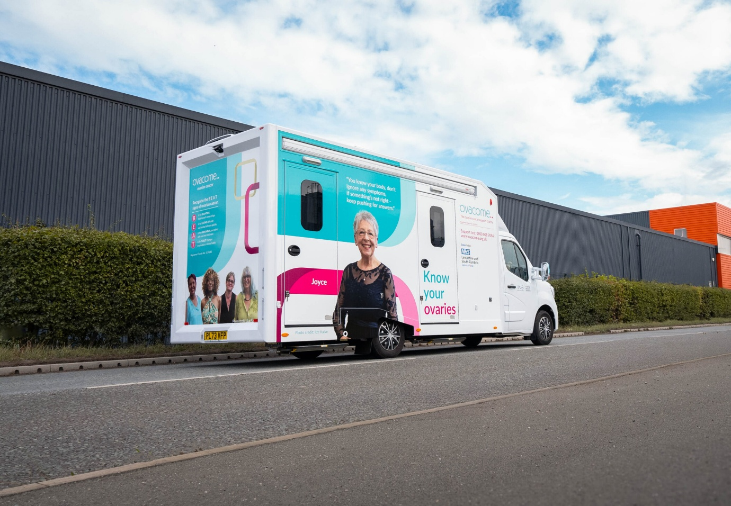
/ General practice / Ovarian cancer van to visit sites across Lancashire and South Cumbria
General practice
Ovarian cancer van to visit sites across Lancashire and South Cumbria
ByDan Clough11 September 2025
From 17 Sept to 18 Oct a branded, eye-catching van will visit town centres, community events and supermarkets, staffed by trained health ambassadors and volunteers offering: interactive ovarian cancer symptom checkers, on-site talks and Q&A sessions, signposting to local support groups and healthcare providers, literature from charity, Ovacome.
More than 7,000 women are diagnosed with ovarian cancer in the UK each year, but survival rates remain stubbornly low, in part because many cases are diagnosed at an advanced stage.
Only around one third of women diagnosed have their cancer caught at stage one or two, with over 50 per cent of cancers diagnosed at advanced stages. A woman has a 95 per cent chance of survival when diagnosed early, more than double the average ovarian cancer survival rate.
The “know your ovaries” campaign aims to transform these outcomes via awareness and education for communities most at risk.
A list of the sites the van will visit is posted here: https://www.lancashireandsouthcumbria.icb.nhs.uk/ovarian-cancer-van

